**Python programs to show the concept of exception handling.**

num1=int(input("Enter a number:"))

num2=int(input("Enter a number:"))

try:

res=num1/num2

except Exception as ob:

print("Division by zero not allowed")

else:

print(num1,'/',num2,'=',res)

print("Thanks")

**OUTPUT**

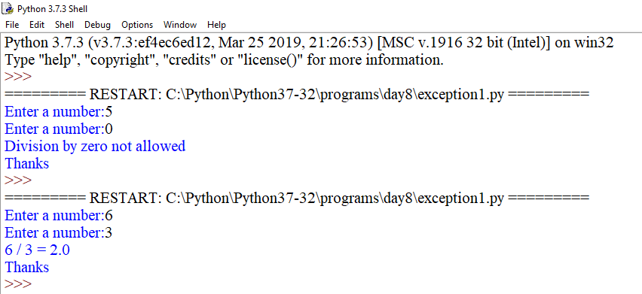

try:

import abc1

except Exception as ob:

print(ob)

try:

num1=int(input("Enter a number:"))

num2=int(input("Enter a number:"))

res=num1/num2

except Exception as ob:

print("Division by zero not allowed")

else:

print(num1,'/',num2,'=',res)

print("Thanks")

**OUTPUT**

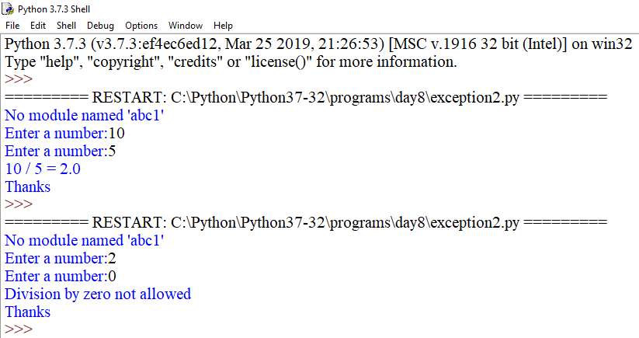

num1=int(input("Enter a number:"))

num2=int(input("Enter a number:"))

try:

res=num1/num2

except ZeroDivisionError as ob:

print("Division by zero not allowed")

else:

print(num1,'/',num2,'=',res)

print("Thanks")

**OUTPUT**

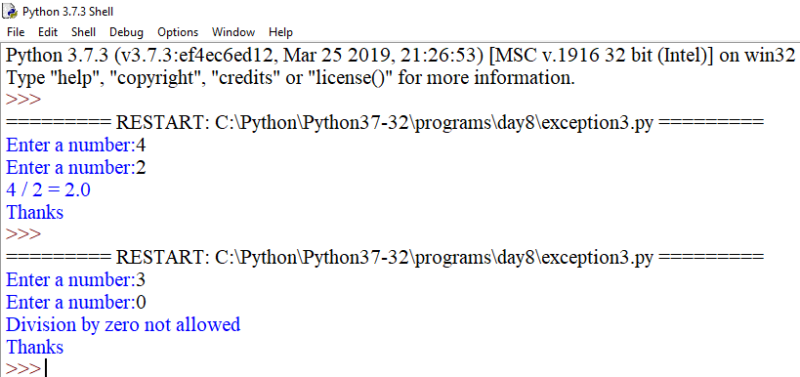

try:

num1=int(input("Enter a number:"))

num2=int(input("Enter a number:"))

except ValueError as ob:

print(ob)

else:

try:

res=num1/num2

except ZeroDivisionError as ob:

print(ob)

else:

print(num1,'/',num2,'=',res)

print("Thanks")

**OUTPUT**

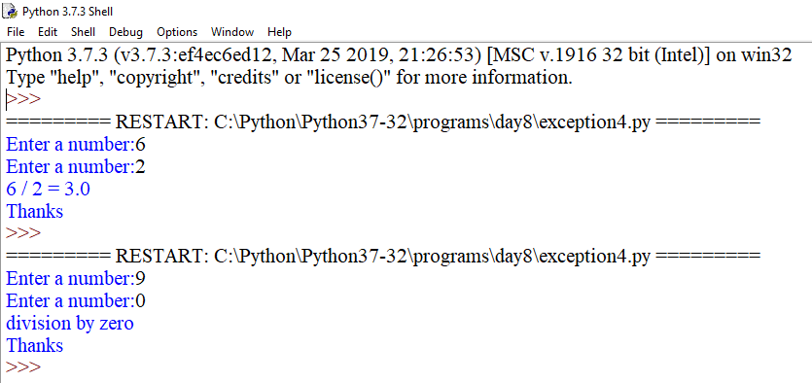

num1=int(input("Enter a number:"))

num2=int(input("Enter a number:"))

try:

res=num1/num2

except ZeroDivisionError:

print("Division by zero not allowed")

else:

print(num1,'/',num2,'=',res)

finally:

print("Resource Deallocated")

**OUTPUT**

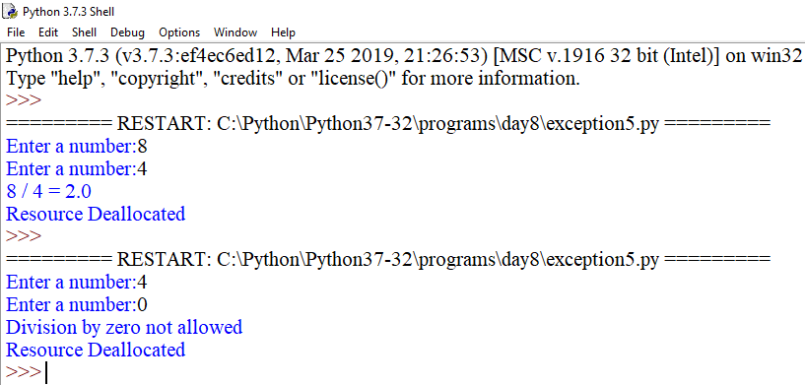

num1=int(input("Enter a number:"))

num2=int(input("Enter a number:"))

try:

fo=open("abcd.txt",'r')

res1=num1+num2

print(res1)

res1=num1/num2

res=int(num1)/int(num2)

except ZeroDivisionError:

print("Division by zero not allowed.")

except ValueError:

print("strings are not allowed. Please input only integers.")

except TypeError:

print("Division on strings are not allowed.")

except Exception as ob:

print(ob)

else:

print(num1,'/',num2,'=',res)

print(num1,'+',num2,'=',res)

finally:

print("Thanks")

**OUTPUT**

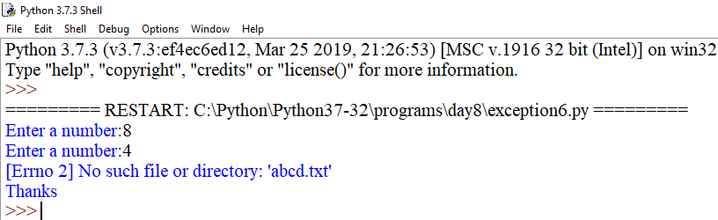

num1=input("Enter a number:")

num2=input("Enter a number:")

try:

#res=num1/num2

res=int(num1)/int(num2)

except (ZeroDivisionError,ValueError,TypeError):

print("Division by zero not allowed or String are not alllowed.\

Please input only integers ")

except Exception as ob:

print(ob)

else:

print(num1,'/',num2,'=',res)

finally:

print("Thanks")

print("Please visit again")

**OUTPUT**

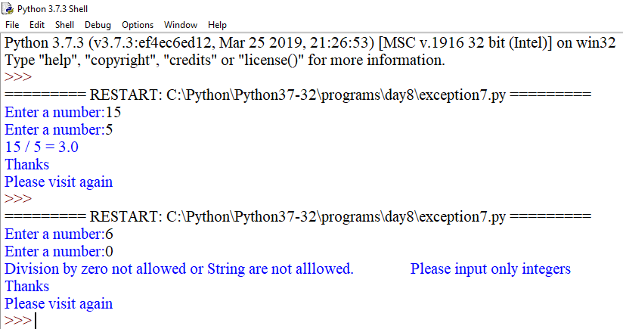

try:

fh=open(r"C:\Python\abcd1.txt","r")

fh.write("This is my test file for exception handling!!")

except Exception as ob:

print(ob)

finally:

print("Error: can\'t find file or read data")

try:

fh.close()

except Exception as ob:

print(ob)

print("Thanks")

**OUTPUT**

